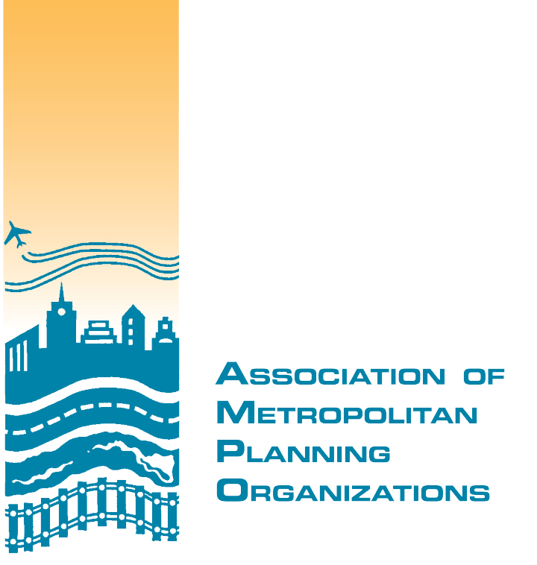
2016 AMPO Sponsorship Agreement

This Agreement is made between the Association of Metropolitan Planning Organizations, a District of Columbia nonprofit corporation (“AMPO”), and the following organization, known as a “Sponsor” throughout this Agreement:

Company name: _____________________________________________________

Contact person: ______________________________________________________

Company address: ____________________________________________________
Number and street City State Zip

AMPO and Sponsor, for mutual consideration, the receipt and adequacy of which are hereby acknowledged, agree as follows:

- Sponsorship. The Sponsor desires to support AMPO’s purposes and missions by associating the Sponsor’s name and logo with the (“Activities”) related to AMPO’s annual conference. Sponsor agrees to make a sponsorship contribution in the amount set forth in Attachment A of this Agreement to support AMPO’s conference, and to abide by the exhibit rules set forth in Attachment B to this Agreement.
- Competition with AMPO. Sponsors desiring to hold events during the AMPO annual conference will not schedule events so as to conflict or hinder participation in any AMPO related activities. All such events should be scheduled during times when no AMPO related activities are held, including one hour prior to beginning to account for arrival of participants.
- Sponsorship events. Sponsorship events using the catering services of the hotel must execute separate catering contracts with the hotel that will not impact catering contracts between AMPO and the hotel.
- Recognition. AMPO will provide appropriate and grateful acknowledgment and recognition of the Sponsor’s support, consistent with applicable provisions of the Internal Revenue Code and Internal Revenue Service regulations; the nature and extent of that acknowledgement and recognition are also described in Attachment A.
- No endorsement. AMPO’s acceptance of the Sponsorship payment does not suggest or convey AMPO’s approval, endorsement, certification, acceptance, or referral of any product or service of the Sponsor.
- Mutual Indemnification. AMPO and the Sponsor each agrees to indemnify and hold harmless the other, as well as the other’s officers, directors, employees, agents, and consultants, from any and all claims, losses, damages, liabilities, judgments, or settlements, including reasonable attorneys’ fees, costs, and other expenses, incurred on account of the indemnifying party’s willful or negligent acts or omissions in connection with participation in AMPO’s conference. The parties shall not be considered to have a partnership, agency, or joint venture relationship. These provisions will survive any cancellation or expiration of this Agreement.
- Mutual Right of Cancellation. Either AMPO or the Sponsor may cancel its participation in AMPO’s annual conference upon (60) sixty calendar days’ advance written notice to the other. In the event the Sponsor cancels prior to (60) sixty calendar days in advance of the conference, AMPO will refund to the Sponsor 75% of the support fee. Cancellations received by AMPO within (60) sixty calendar days in advance of the conference, will result in no refund to the Sponsor.

Agreed to this _____________ day of ______________________________, 20______

On behalf of Sponsor: _________________________________ _________________________________
Signature Printed name/Title

Accepted by AMPO: _________________________________ _________________________________
Signature Printed name/Title
ATTACHMENT A
Sponsor Levels and Recognition*

At the PLATINUM LEVEL ($7,500 contribution), you receive:
- 3 complimentary registrations (including admission to workshops* and meals)
- Sponsor (recognition at the sponsored event and sponsor name placard displayed on tables)
- Opening Reception
or
- Conference Meal
Lunch
- Sponsor’s promotional material placed on each chair for lunch or gift bag for each attendee at reception (sponsor must provide material(s))
- Placement of your company’s promotional flyer (8 ½ x11 or tri-fold brochure) in conference attendees’ registration packets
- A designated draped exhibit table
- Conference Attendee Mailing List
- Name and Logo in the official conference program, on the conference webpage, and prominently displayed at the actual event
At the GOLD LEVEL ($5,000 contribution), you receive:
- 2 complimentary registrations (including admission to workshops* and meals)
- Coffee break sponsor with name prominently displayed on site
- Placement of your company’s promotional flyer (8 ½ x 11 or tri-fold brochure) in conference attendees’ registration packets
- A designated draped exhibit table
- Conference Attendee Mailing List
- Name and Logo in the official conference program, on the conference webpage, and prominently displayed at the actual event
At the SILVER LEVEL ($3,000 contribution), you receive:
- 2 complimentary conference registrations (including admission to workshops* and meals)
- A designated draped exhibit table
- Conference Attendee Mailing List
- Name and Logo in the official conference program, on the conference webpage, and prominently displayed at the actual event

At the BRONZE LEVEL ($1,500 contribution), you receive:
- 1 complimentary registration (including admission to workshops* and meals)
- Name and Logo in the official conference program, on the conference webpage, and prominently displayed at the actual event

At the LOGO SPONSOR LEVEL ($850 contribution, for companies with 25 employees or less), you receive:
- Name and Logo in the official conference program, on the conference webpage, and prominently displayed at the actual event
- Company brochure on information table next to conference registration
*Mobile and pre-conference workshop fees are not included in complimentary registration(s).
* Exhibit tables and mailing list are not sold by AMPO and do not have any cash value.

ATTACHMENT B
EXHIBITION RULES

Specifications
Exhibitor Area: TBD
Maximum Number of Exhibitors: 20
Furniture Provided to Each Exhibitor: 1 standard table (approx. 6') and 2 chairs
Exhibitor Set-Up: Tuesday, October 25, 10 am to 12 pm
Shipping: AMPO is currently working with the hotel to confirming shipping information. More information will be provided closer to the event.
Exhibitor Break-Down: Anytime after 6:30 pm on Thursday, October 27
Table Assignments
Exhibitors will be able to choose their space on a first come, first serve basis.
Hours
The exhibit area will be open on Tuesday, October 25, noon to 4:30 pm, and all day on Wednesday, October 26 and Thursday, October 27.

Exhibitor Passport - Raffle
In the registration packet, conference attendees will be provided with an exhibitor passport, which will include all of the exhibitor names. Attendees must obtain the stamps of all the exhibitors on the passport provided to them. The completed exhibitor passport must be returned to the conference registration to be entered into a raffle. During the Thursday happy hour, we will draw a winner for a special prize. The person drawn MUST be present to win.

