The Lake Havasu Metropolitan Planning Organization (LHMPO)
is seeking a highly motivated and experience leader as its next
METROPOLITAN PLANNING OFFICER
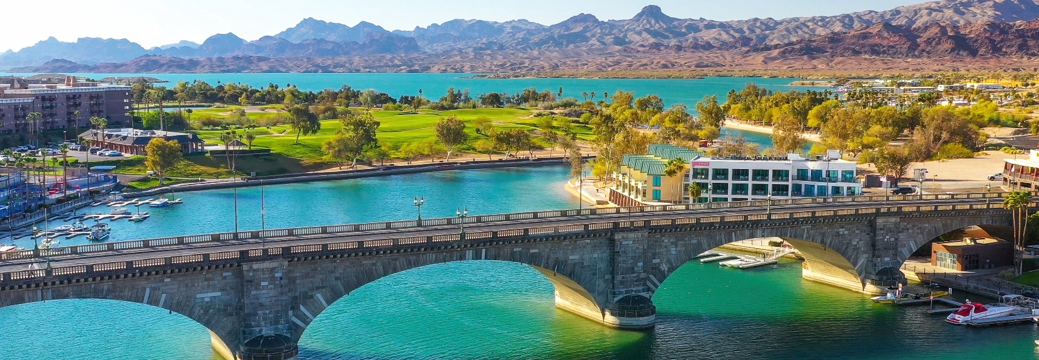
About Our Community:
Lake Havasu City, located in western Arizona, along the Colorado River, is renowned for its stunning desert landscape, outdoor recreational opportunities, and vibrant community life.
Situated in Mohave County, Lake Havasu City is characterized by its desert terrain and rugged mountains, rocky landscapes, and the iconic Lake Havasu.
The centerpiece of the city is Lake Havasu, a large reservoir formed by the Parker Dam on the Colorado River. Spanning 45 miles in length, this area is renowned for its recreational opportunities, including boating, fishing, swimming, and watersports.

About the Lake Havasu Metropolitan Planning Organization:
The Lake Havasu Metropolitan Planning Organization (LHMPO) is located in beautiful Lake Havasu City, Arizona. The LHMPO is one of 6 MPOs in the state and incorporates all areas within the Lake Havasu City limits, the Mohave County area north of the city limits known as Desert Hills, Havasu Gardens, Crystal Beach and the Mohave County area south of the City known as Horizon Six. The planning area of the MPO is approximately 100 square miles.
The mission of the Lake Havasu Metropolitan Planning Organization (LHMPO) is to provide open leadership and guidance for regional transportation planning through a cooperative effort that will result in a practical and positive growth model beneficial to residents, visitors and businesses.
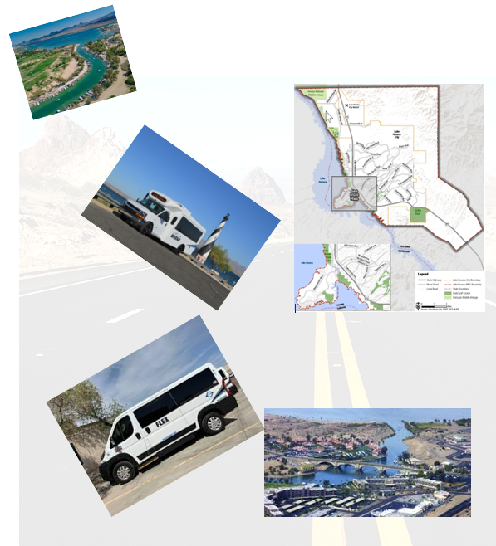
THE IDEAL CANDIDATE
- Excellent leadership, management, and communication skills
- Proven ability to lead, support and develop team members within their areas of focus and expertise.
- Demonstrated ability and willingness to interact effectively with elected officials, and executive level staff on state and federal governments and with federal agencies.
- Experience in metropolitan and statewide transportation planning process and government operations.
- Strategic thinking and knowledge and ability to collaborate with various stakeholders to identify and implement strategic transportation goals.
- Strong administrative background with financial management.
JOB RESPONSIBILITIES INCLUDE:
- Supervises LHMPO staff to include assigning and monitoring work, prioritizing work, training staff, making suggestions for performance adjustments, determining disciplinary actions, and evaluating staff performance.
- Prepares, submits, and monitors Federal and State grant funds and funding allocations to ensure funds are expensed in accordance with grant agreements, ADOT contract, federal and state laws.
- Develops and implements an effective Unified Planning Work Program approved by ADOT and FHWA.
- Reviews and interprets complex planning documents.
- Conducts research and prepares written communication and reports regarding projects and activities.
- Manages public transportation planning and studies.
- Develops and maintains a Regional Transportation Plan.
- Coordinates and executes transportation plans with City, County, State and Federal Officials.
- Prepares and executes contractual documents; prepares and submits reports.
- Updates and reports all federal and state required documents.
- Attends meetings as needed to represent the LHMPO.
- Conducts public meetings in accordance with Arizona Open Meeting Laws.
- Develops, coordinates, and facilitates presentations to the general public and outside agencies.
- Prepares and administers the LHMPO budget and exercises control over expenditures.
- Operates and maintains motor vehicles or other work -related equipment requiring a valid Driver License.

QUALIFICATION AND EXPERIENCE:
The successful candidate holds a bachelor's degree in Transportation Engineering, Planning, or a closely related field and four (4) years’ experience in transportation governmental planning, capital improvements and/or project planning and management, or equivalent combination of education and experience. Master's degree is preferred.
This is an executive/appointed position that serves at the pleasure of the LHMPO Board of Elected Officials.
COMPENSATION AND BENEFITS:
The hiring range for the position is $3,269.23 - $4,230.77/Bi-Weekly; DOQ. The salary of the successful candidate will be negotiated within the above stated range with the LHMPO Board and Elected Officials and will be based upon qualifications.
This position includes a superior benefits package, including a comprehensive health benefit plan offering medical Rx, dental, vision coverage for employee and their eligible dependents. City paid life insurance with option to increase coverage through voluntary life election. short-term disability, retirement through Arizona State Retirement System (ASRS), optional deferred compensation opportunities, eleven (11) paid holidays and paid time off that increases with longevity.
APPLICATION AND SELECTION PROCESS:
To be considered for this exceptional opportunity, please submit your application, along with a resume and a cover letter which includes your salary expectation, on the City's Career Opportunities Page at www.lhcaz.gov.
Applications are accepted until an adequate pool of applicants have applied. First review of applicants will take place two (2) weeks after posting and as needed afterwards. This posting is subject to close at any time, so you are highly encouraged to apply early.
Candidates are screened against criteria provided in this brochure and job specifications. Only the most highly qualified candidates will receive consideration. Candidates selected to move forward in the recruitment process are subject to criminal history, driver license, educational credentials, and personal background checks.
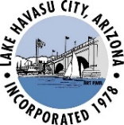
For questions related to this position, please contact Human Resources
at (928) 453-4143 or send an email inquiry to hr@lhcaz.gov with MPO in the subject line.

